Pelagos_CST16_2024_Doc02

English

Distribution: 26/03/2024

Template letter for project support under the Pelagos Agreement Management Plan

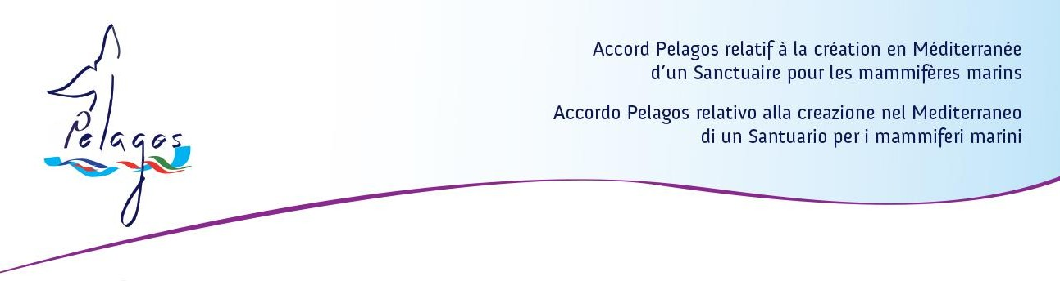

Principality of Monaco, [Date]
Ref:
Subject: Endorsement letter for [Name of the project / researcher / etc…]

Dear […] / To Whom It May Concern,
The Permanent Secretariat of the Pelagos Agreement expresses its endorsement and gives its in-principle support to the [Name of the project / researcher / etc…].
The Permanent Secretariat of the Pelagos Agreement recognizes the interest on support the [Name of the project / researcher / etc…] being the project linked to the general objectives of the Management Plan 2022-2027 and vision of the Pelagos Agreement, in particular in the areas of […].
However, the Permanent Secretariat asks the project manager to contribute to the Pelagos Agreement work by regularly reporting to the Pelagos Scientific and Technical Committee on the progress and results of the reaserches.
The Pelagos Agreement considers of interest the collaboration with [Name of the project / researcher / association, etc…] and, when and if possible, it will support the research by facilitating contacts, if needed, with all stakeholders in the Pelagos Sanctuary.
I seize the opportunity of this communication to wish all the success in the implementation of this research project.
Yours sincerely,

[Signature]

