Pelagos_CST15_2023_Doc02
English/French/Italian
Distribution: 29/07/2023

THE CUVIER’S BEAKED WHALE AND IMPULSIVE UNDERWATER NOISE IN THE MEDITERRANEAN SEA

THE CUVIER’S BEAKED WHALE AND IMPULSIVE UNDERWATER NOISE IN THE MEDITERRANEAN SEA
(version updated as of 18/07/2023)
Photo: Massimiliano Rosso, CIMA Foundation | Figure 1. Areas with known resident groups and important habitats for Cuvier’s beaked whales. Modified from Podestà et al. 2016. The dotted red lines show the boundaries of the Pelagos Sanctuary.
1. The Cuvier’s beaked whale and impulsive noise
The Mediterranean population of Cuvier’s beaked whales comprises about 5,800 individuals (Cañadas et al. 2018) and is listed as Vulnerable by the IUCN Red List (Cañadas and Notarbartolo di Sciara 2018). The importance of the Pelagos Sanctuary for the Mediterranean population of Cuvier’s beaked whale (Ziphius cavirostris) is highlighted in various sources. In 2016, the IUCN reiterated the importance of the Sanctuary for this species by identifying the Important Marine Mammal Area (IMMA) of the Western Ligurian Sea and Genoa Canyon, which identifies Cuvier’s beaked whale critical habitats in this area. Podestà et al. 2016 (Figure 1) also summarised knowledge on the distribution and residence of the species showing that two out of the five important areas for this species Mediterranean population are located within the Sanctuary. These two areas are used by at least 400 individuals (Massimiliano Rosso, CIMA Foundation photo-identification database).
Beaked whales are known to be sensitive to a wide range of man-made noise (Aguilar de Soto et al. 2006). In particular, they have a negative reaction to a class of impulsive noises, especially those produced by military anti-submarine sonars. These types of noises are believed to provoke abrupt behavioural responses that affect their normal diving behaviour resulting in lethal “decompression sickness” leading to mass strandings. In some cases, exposure to these high energy sounds can cause direct injuries to fundamental tissues (for a review, see Bernaldo de Quiros et al. 2019). The link between military sonars and mass strandings of beaked whales was first suggested in 1996 in Greece, where an atypical event of this kind occurred near a military exercise area (Frantzis 1998). This event was brought to global attention, stimulating major scientific efforts especially by the NATO Underwater Research Center (NURC). They found that cetacean responses to military sonar varied by species and areas, but confirmed that in the Mediterranean case the deadly correlation between military exercises and mass strandings was significant for Cuvier’s beaked whales (Filadelfo et al. 2009). In this regard, NURC also drew up its own “Marine Mammal Risk Mitigation Rules and Procedures” (2009).

In 2013, the Scientific Committee of the Agreement on the Conservation of Cetaceans of the Black Sea, Mediterranean Sea and Contiguous Atlantic Area (ACCOBAMS) underlined that "during naval exercises using sonar or underwater explosions, there should be absolute avoidance within an approximate 90 km buffer zone around all areas that have been designated as ‘Areas of Special Concern for Beaked Whales’ in the Mediterranean Sea”. At present, the best available map that represents the “Areas of Special Concern” for this species is the one in Figure 2 (source: Cañadas et al. 2018). This map reiterates the importance of the Pelagos Sanctuary and surrounding regions (dark areas).

Figure 2. Distribution of Mediterranean Cuvier’s beaked whales (Source: Cañadas et al. 2018)
2. Legal context of the Agreement and measures adopted at a national level
The legal context in which Pelagos Parties operate on the effects of military impulsive noise on Cuvier’s beaked whales is clarified by the text of the Pelagos Agreement (Table 1). This also provides guidance on how the Parties should ensure full consistency between the legitimate ‘sovereign immunity’ and the Agreement’s overall objective, i.e. "to guarantee a favourable conservation status of marine mammals by protecting them and their habitat, from direct or indirect negative impacts of human activities” (see art. 15 and 4, respectively).
Table 1 - Legal context of the Agreement
Article 15
Rien dans le présent accord ne porte atteinte à l’immunité souveraine des navires de guerre ou autres navires appartenant à/ou exploités par un Etat pendant qu’ils sont affectés à un service public non commercial. Toutefois, chaque Etat Partie doit s’assurer que ses navires et aéronefs qui jouissent d’immunité souveraine selon le droit international agissent d’une manière compatible avec le présent accord. | Nulla nel presente Accordo può mettere in discussione l’immunità sovrana delle navi da guerra od altre navi appartenenti o comunque utilizzate da uno Stato, nella misura in cui sono adibite ad un servizio pubblico non commerciale. Tuttavia, ogni Stato Parte deve accertarsi che le sue navi e aeromobili che godono di immunità sovrana secondo il diritto internazionale agiscano secondo modalità compatibili con il presente Accordo. | Nothing in this Agreement affects the sovereign immunity of warships or other vessels owned/operated by a State while on government non-commercial service. However, each State Party shall ensure that its ships and aircraft which enjoy sovereign immunity under international law act in a manner consistent with this Agreement.
Article 4
Les Parties s’engagent à prendre dans le sanctuaire les mesures appropriées mentionnées aux articles ci-après pour garantir un état de conservation favorable des mammifères marins en les protégeant, ainsi que leur habitat, des impacts négatifs directs ou indirects des activités humaines. | Le Parti si impegnano a prendere nel Santuario le misure appropriate indicate agli articoli seguenti, per garantire uno stato di conservazione favorevole dei mammiferi marini proteggendoli, insieme al loro habitat, dagli impatti negativi diretti o indiretti delle attività umane. | The Parties undertake to take appropriate measures in the Sanctuary indicated in the following articles, to ensure a favourable conservation status of marine mammals by protecting them, together with their habitat, from direct or indirect negative impacts of human activities.
As for national contexts, in France the Ministry for Ecological Transition has compiled a guide of recommendations for central and decentralised State services to limit the impacts of acoustic emissions of anthropogenic origin on marine fauna. Guidelines can be downloaded in French and English. Although “these guidelines […] exclude from their scope noise emissions related to military activities”, the French Navy uses them and also uses a guide by such Ministry on military activities (2013) and a Navy internal directive on sonars. Moreover, geo-seismic surveys using airguns for scientific exploration or for the exploitation of hydrocarbons in French waters must be authorised according to standard procedures related to the Environmental Impact Assessment.
In Italy, the Convention on Migratory Species (CMS) guidelines on activities involving the emission of impulsive sounds have been adopted. Their implementation is a requirement in integrated environmental impact assessment procedures as well as in strategic environmental assessment procedures. Moreover, Legislative Decree 152/2006 (and following amendements) prohibits geo-seismic activities in all protected areas and in a surrounding buffer zone of 12 nautical miles, including in the Specially Protected Area of Mediterranean Importance “Pelagos Sanctuary”. Every year, ISPRA prepares a report submitted to the Italian Parliament on the effects of the use of airguns in Italian waters. Finally, the Italian Navy applies standard measures to minimise the impact on cetaceans, such as: (a) monitoring the possible presence of cetaceans before and during the use of active sonars; and (b) defining the most appropriate powers to reduce the environmental impact. The protocols used by the Italian Navy were written with the support of ISPRA and make use of acoustic profiles of all Mediterranean species and of available distribution maps with the areas of greatest importance for ‘deep diving marine mammals’.
3. Other available guidelines and a recommended minimum bibliography
- Marine Strategy Framework Directive (MSFD; 2008/56/EC)  - Common implementation strategy: setting of EU threshold values for impulsive underwater noise - Recommendations from the Technical Group on Underwater Noise (TG Noise)  - Common implementation strategy: setting of EU threshold values for continuous underwater sound - Recommendations from the Technical Group on Underwater Noise (TG Noise) | NATO’S NURC GUIDELINES (2009)
An easy and short reading on how and why military sounds affect Cuvier’s beaked whales, in English and French, published by Whales Online, a Canadian magazine and encyclopaedia. 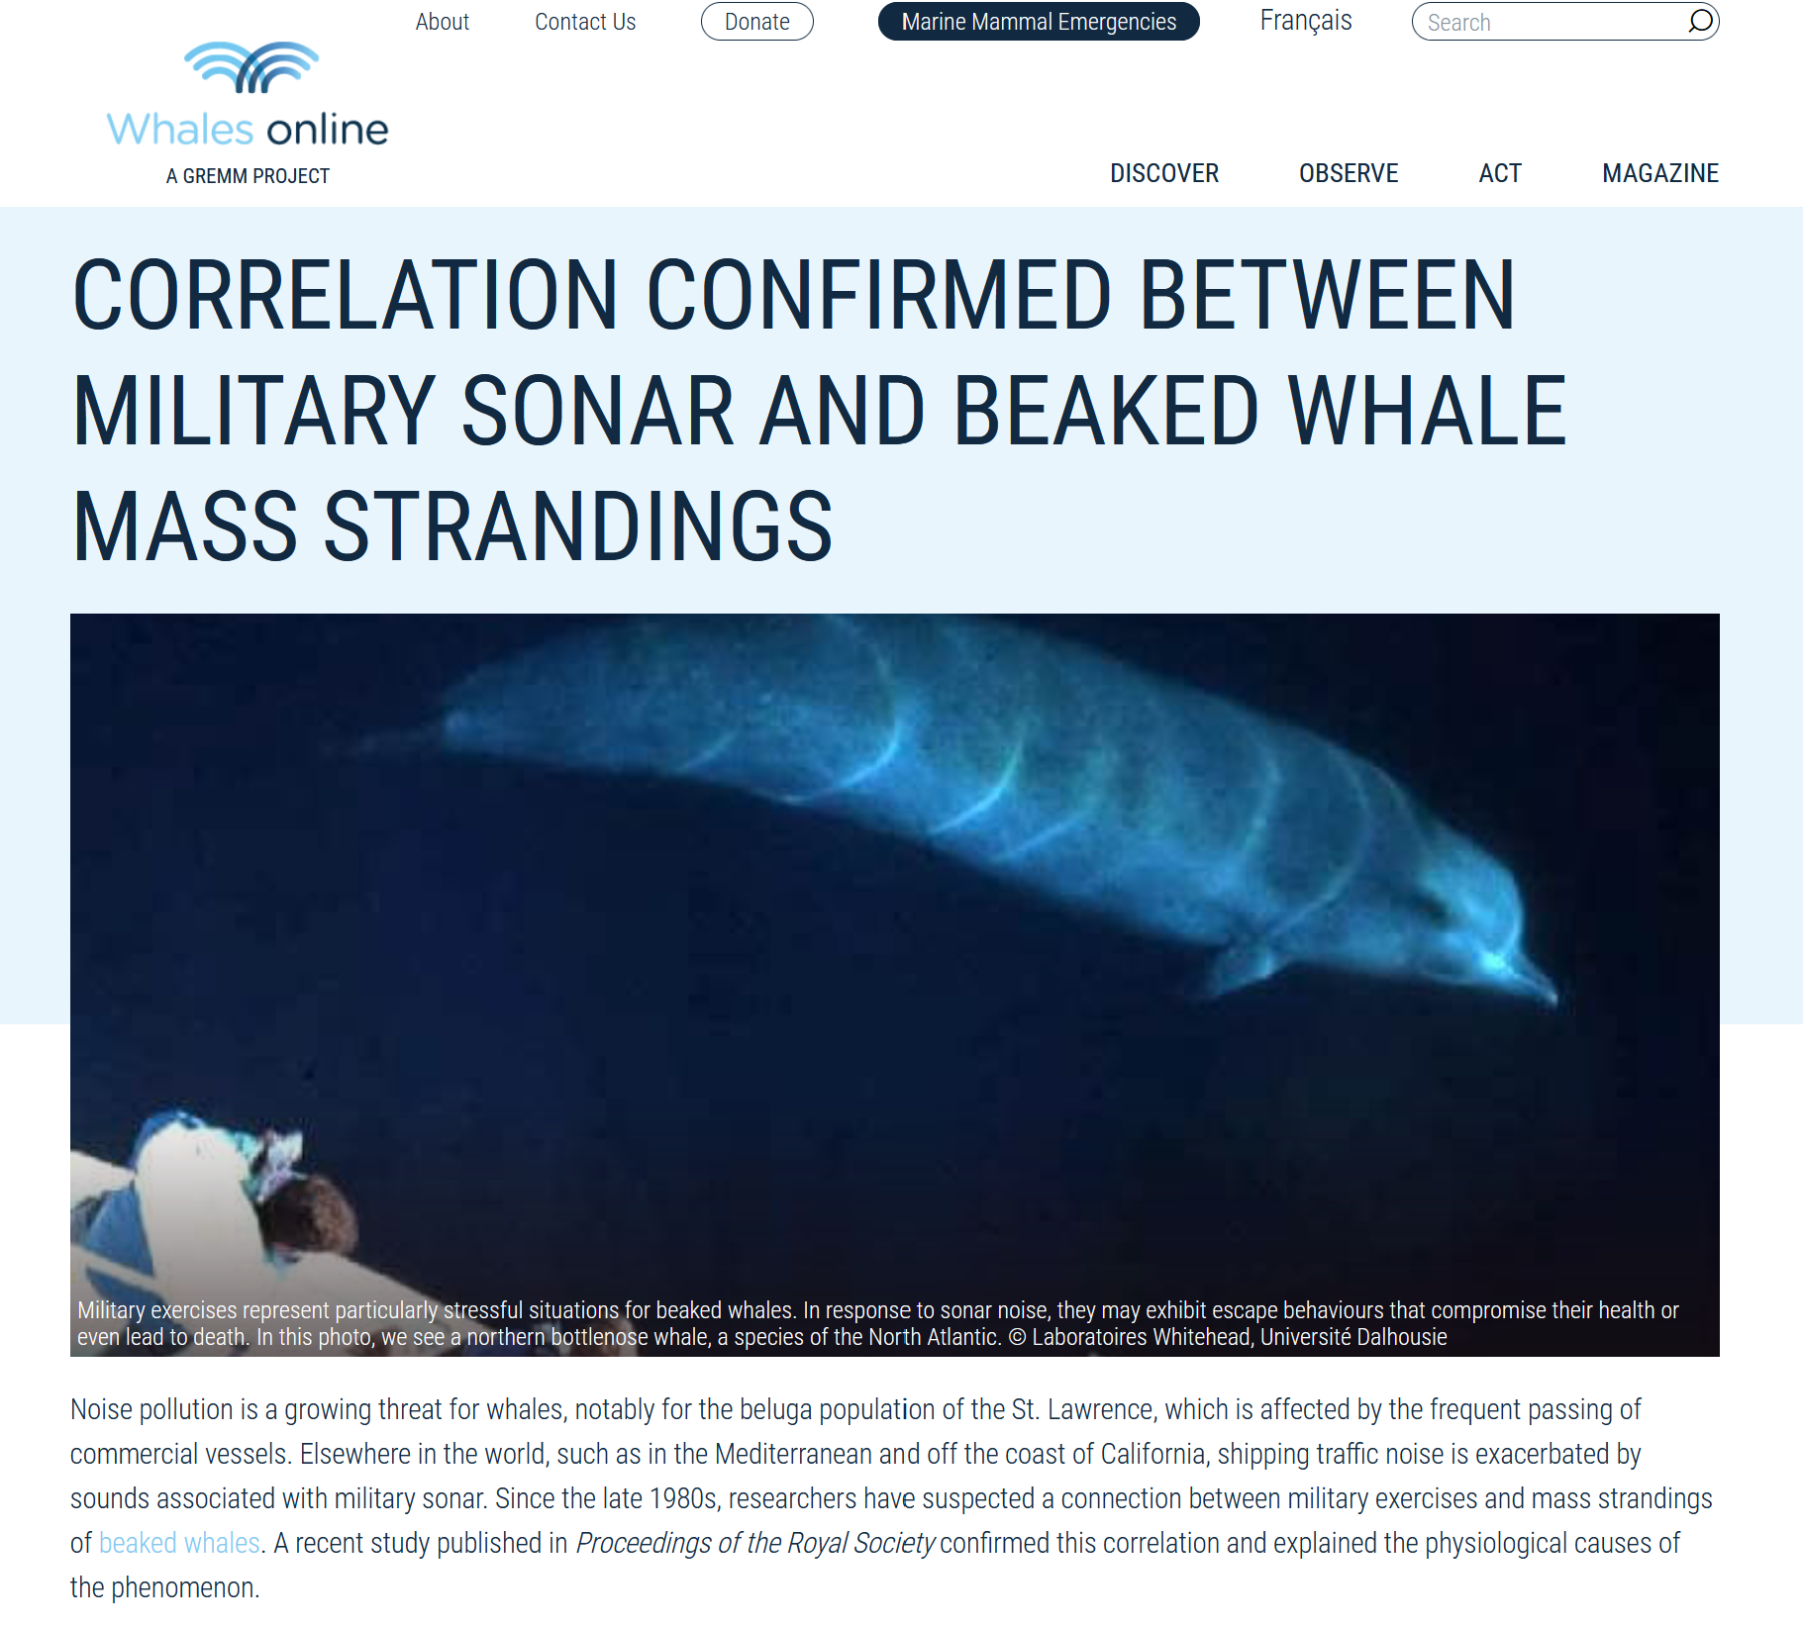 | Paper by Bernaldo de Quirós and colleagues (2019) on Advances in research on the impacts of anti-submarine sonar on beaked whales, which summarises all technical aspects of this issue.
Cañadas et al. (2018) mentions the Pelagos Sanctuary among the areas with the highest density of Cuvier’s beaked whales (red areas in Fig. 1 and 3). It also provides an abundance estimate for the whole Mediterranean Sea and offers some considerations on management implications. | Frantzis (1998) was the first scientist linking Cuvier’s beaked whales’ atypical mass strandings to military sonars.
Filadefo et al. (2009) is one of the several studies by NURC that examined claims from Frantzis (1998).  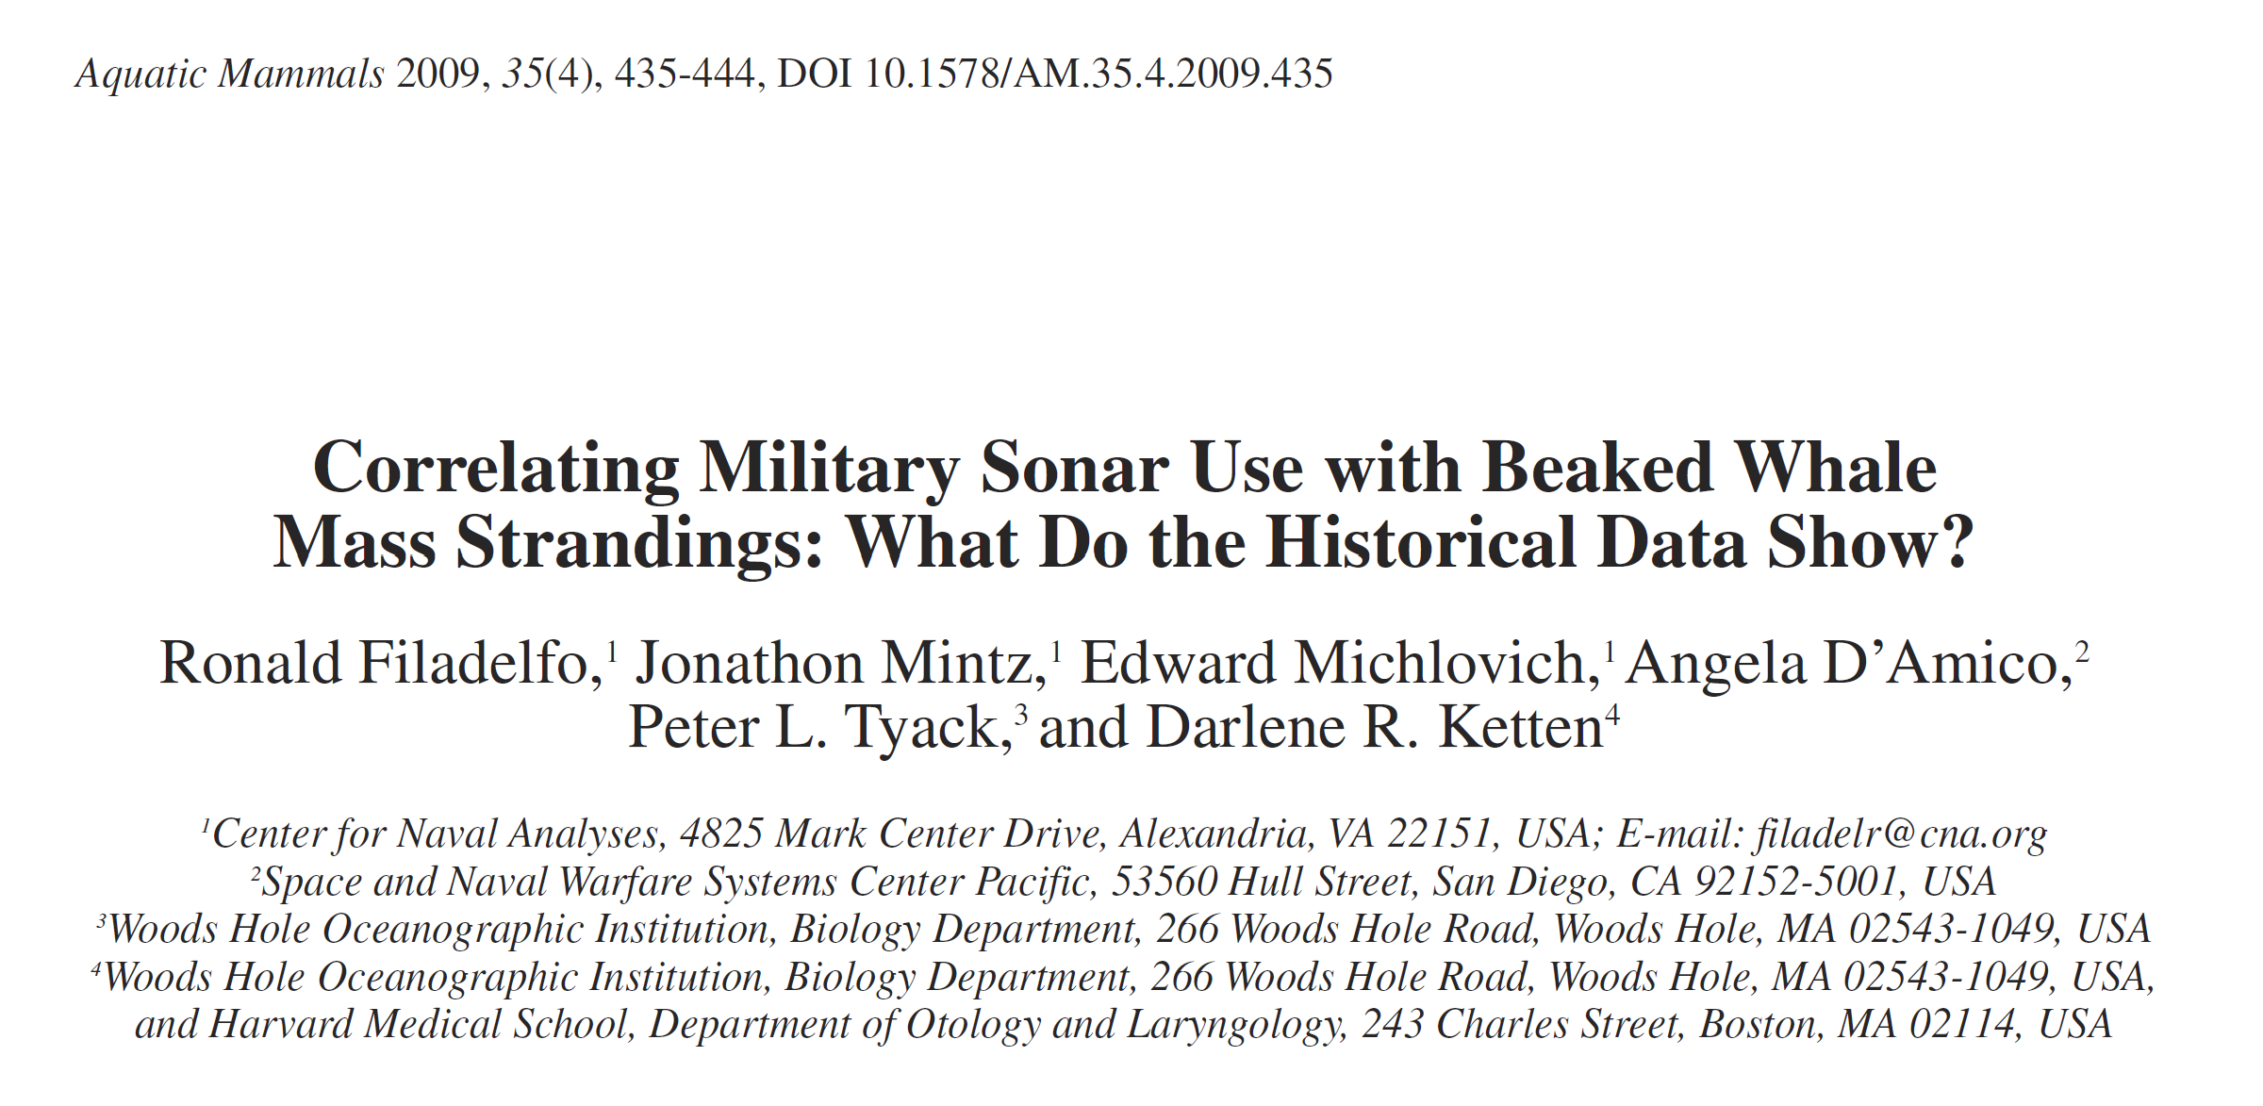 | Basat's Cuvier's Beaked Whale Mass Stranding Event (preliminary report) summarises some information on a recent mass stranding of 12 beaked whales that occurred in February 2023 off the south coast of Turkey and north of Cyprus. This event occurred while extensive navy exercises were taking place and carcasses showed clear signs of gas embolism.

4. Concerns raised by the Pelagos Working Group on Impacts
Recognising the right of the countries to undertake military exercises, the Pelagos Working Group on Impacts emphasises that:
- The Pelagos Sanctuary is an important habitat for the Cuvier’s beaked whale and contains two out of five Mediterranean areas with the highest density for this species.
- The Cuvier’s beaked whale - classified by the IUCN in the Mediterranean Sea as Vulnerable (2018) - is a protected species under the ratification laws of the Barcelona Convention and its protocols, and in France and in Italy also under the EU Habitats Directive (Annex IV).
  - Under the EU Habitats Directive, “Military, paramilitary or police exercises and operations in the marine environment (H02)” is a class of pressures and threats recognised as “of high impact” for this species that needs to be reported when implementing art. 17 of the Directive. Moreover, France and Italy must minimize the human-induced disturbance to species listed in Annex IV and to their habitats.
- Article 15 of the Pelagos Agreement must take into account the overall objective of the Agreement as set out in Article 4.
- Pelagos Parties, which are also Parties to the Convention on Migratory Species (CMS) and ACCOBAMS, have adopted the following decisions:
    - ACCOBAMS Resolutions 4.17 (2010) and 7.13 (2019) on Anthropogenic noise, including the “Guidelines to address the impact of anthropogenic noise on cetaceans in the ACCOBAMS area” which, inter alia, recommended that “extra mitigation measures should be applied in deep water areas if beaked whales have been seen diving on the vessel track line or if habitats suitable for beaked whales are approached”. Ideally, “sonar exercises should not be done in areas that beaked whales are known to inhabit”.
    - ACCOBAMS Resolution 5.13 (2013) on Conservation of Cuvier’s beaked whales in the Mediterranean, in which the Parties agreed that “Cuvier’s beaked whales need special consideration” and that “the concept of areas of special concern in which noise would be mitigated should be enhanced […]”.
    - CMS Resolution 12.14 (2017) on Adverse Impacts of Anthropogenic Noise on Cetaceans and Other Migratory Species and its Annex “CMS Family Guidelines on Environmental Impact Assessment for Marine Noise-generating Activities”, including a section on EIA Guidelines for Military and Civil High-powered Sonars. CMS Resolution 12.14 is calling on Parties and invites non-Parties “to adopt, whenever possible, mitigation measures on the use of high intensity active naval sonars until a transparent assessment of their environmental impact on marine mammals, fish and other marine life has been completed”. In particular, Parties must “aim to prevent impacts from the use of such sonars especially in areas known or suspected to be important habitat to species particularly sensitive to active sonars (e.g. beaked whales)” and “where risks to marine species cannot be excluded, taking account of existing national measures and related research in this field”.

The Pelagos Working Group on Impacts respectfully recommends the Secretariat to urge Pelagos Parties to:
- fully implement their commitments under the Pelagos Agreement, the Convention on Migratory Species (CMS), ACCOBAMS and EU Habitats Directive, in particular by
  - establishing a higher level of protection for this species in relation to their habitat and the use of adverse type of impulsive noise, within and outside the Sanctuary, in line with the suggested ACCOBAMS approach of a 90 km buffer zone around Cuvier’s beaked whale habitat, free from impulsive noise produced by military airguns and submarine sonars, for example by:
    - maintaining the attention of relevant NATO bodies and national Navy representatives on this issue and on the necessity to periodically update the strategies to minimise risks for this highly sensitive species;
    - implementing two aspects of the ACCOBAMS guidelines (Section A, letters “n” and “p”) by:
      - developing a pre-alert system for military exercises occurring in waters adjacent the Pelagos Sanctuary, so that national stranding networks can coordinate and increase the surveillance on dead animals along the coasts and at sea and, in suspicious cases,
      - devoting the maximum effort to understanding the causes of deaths, through the finalisation of a standardised protocol to identify cases of human-induced mortality and the support to the necessary specialised veterinary training.
The Working Group also proposes the creation of a dedicated section on Cuvier’s beaked whales and impulsive noise on the Pelagos Sanctuary institutional website, based on the information included in the previous sections.
Finally, in terms of the potential development of the WGs agenda, the Working Group on Impacts proposes to:
- create a sub-group on noise drafting a handbook based on ACCOBAMS and CMS guidelines to mitigate the impact of impulsive sounds on marine mammals in the areas of interest of the Pelagos Sanctuary;

- recommend the Assessment WG to give priority to the re-evaluation of the habitat of Cuvier’s beaked whales within and outside the Pelagos Sanctuary, based on all available information. This work would help improve and update the maps produced by Cañadas and colleagues (2010 and 2018) on the Pelagos Sanctuary and surrounding regions.

